Skill Gap Analysis & Prediction

A PROJECT REPORT
Submitted by
DEBASHISH PANDA
PRIYADARSANI PANDA

in partial fulfillment for the award of the degree of
MASTER
in
COMPUTER APPLICATIONS

SCHOOL OF APPLIED SCIENCE
BHUBANESWAR CAMPUS
CENTURION UNIVERSITY OF TECHNOLOGY AND MANAGEMENT
ODISHA
NOV 2026

DEPARTMENT OF MASTER IN COMPUTER APPLICATIONS SCHOOL OF APPLIED SCIENCE
BHUBANESWAR CAMPUS

BONAFIDE CERTIFICATE

Certified that this project report Skill Gap Analysis & Prediction
is the bonafide work of “DEBASHISH PANDA”, “PRIYADARSANI PANDA” who carried out the project work under my supervision. This is to further certify to the best of my knowledge, that this project has not been carried out earlier in this institute and the university.
<<Signature of the Supervisor>>
SIGNATURE

(Prof. Saroj Kumar Sahoo)
Professor of Computer Science and Engineering

Certified that the above-mentioned project has been duly carried out as per the norms of the college and statutes of the university.

SIGNATURE
(Prof. Rakesh Kumar Ray) HEAD OF THE DEPARTMENT
Professor of Computer Science and Engineering

DEPARTMENT SEAL

DECLARATION

I hereby declare that the project entitled “Skill Gap Analysis & Prediction” submitted for the “Major Project” of 3rd semester MCA in Computer Science and Engineering is my original work and the project has not formed the basis for the award of any Degree or any other similar titles in any other University / Institute.

Name of the Student: Debashish Panda
Priyadarsani Panda

Signature of the Student:

Registration No:240720100091
240720100059
Place: CUTM, BHUBNESWAR CAMPUS

Date:

ACKNOWLEDGEMENT

I wish to express my profound and sincere gratitude to Mrs. Maiyetree Mohanty, Department of Computer Science and Engineering, SoET, Bhubaneswar Campus, who guided me into the intricacies of this project nonchalantly with matchless magnanimity.
I thank Prof. Rakesh Kumar Ray, Head of the Department of Master in Computer Applications, SoET, Bhubaneswar Campus and Prof. Sujata Chakravarthy, Dean, School of Engineering and Technology, Bhubaneswar Campus for extending their support during Course of this investigation.
I am highly grateful to Mrs. Maiyetree Mohanty who evinced keen interest and invaluable support in the progress and successful completion of my project work.
I am indebted to Mr. Trilochan Sahoo for their constant encouragement, co- operation and help. Words of gratitude are not enough to describe the accommodation and fortitude which they have shown throughout my endeavor.

Name of the Student: Debashish Panda
Priyadarsani Panda

Signature of the Student:

Registration No:240720100091
240720100059

Place: CUTM, BHUBNESWAR CAMPUS

TABLE OF CONTENTS

CHAPTER NO. TITLE PAGE NO.

CERTIFICATE i
DECLARATION ii
ACKNOWLEDGEMENT iii
- ABSTRACT 01
- INTRODUCTION 02
- INTODUCTION ABOUT DATASET 03
- LIBRARIES USED 04-05
- CLASSIFICATION AND VISUALIZATION 06-12
- SPLITTING AND MODEL IMPLEMENTATION 13
- ACCURACY OF ALL MODELS 13
- BUILDING A USERINPUT PREDICTIVE SYSTEM 14-15
- CONCLUSION 16
- FUTURE SCOPE 17
- REFERENCE 18

​Abstract

This report presents the major-project assigned to Third semester MCA student in the field of Machine Learning for Predictive Analysis, under the guidance of the Department of Computer Science and Engineering. Diabetes is one of the fastest-growing health challenges in the world, affecting millions of people across all demographics. Early diagnosis and intervention can significantly help in managing the disease and preventing severe complications such as cardiovascular issues, kidney failure, and nerve damage. However, due to the chronic nature of the disease and the lack of resources for continuous patient monitoring, early detection remains a challenge. In this project, we have explored and implemented machine learning models to predict diabetes based on various health attributes of patients. Using publicly available datasets from Kaggle, we applied algorithms such as logistic regression, decision trees, and random forest. The performance of these models was evaluated using accuracy scores, confusion matrices, and cross-validation techniques. This project highlights the potential of machine learning in developing efficient and accessible diagnostic tools for diabetes prediction, which can support healthcare providers and help in early intervention for at-risk individuals.

Introduction
According to the World Health Organization, diabetes is one of the leading causes of death and disability worldwide, with millions of new cases diagnosed every year. The burden of diabetes has been increasing rapidly across both developed and developing nations due to lifestyle changes, unhealthy diets, and genetic factors. Numerous studies have been conducted to identify the key risk factors and to develop reliable methods for predicting the onset of diabetes in individuals. Diabetes is often called a silent condition, as it may remain undiagnosed for years while gradually causing serious health issues.The early diagnosis of diabetes plays a crucial role in taking preventive actions and adopting lifestyle modifications to manage the condition effectively and reduce complications. This project aims to predict the likelihood of diabetes by analyzing patient data using machine learning algorithms that classify whether an individual is diabetic or not. One of the major challenges in diabetes management is its early detection, especially among asymptomatic individuals. Although there are several medical tests available for diabetes detection, they can be time-consuming, expensive, or inaccessible in remote areas.With the abundance of healthcare data available today, machine learning techniques offer an efficient way to identify hidden patterns that contribute to the onset of diabetes. In this project, we utilize various algorithms to build predictive models that can assist in early detection and help medical professionals provide timely intervention. This approach not only supports better health outcomes but also has the potential to significantly reduce the economic and clinical burden of diabetes on society.

INFORMATION ABOUT DATASET:

- Data used: -Diabaties Dataset
- Size: -68 MB
- SOURCE OF OLLECTION –
KAGGLE https://www.kaggle.com/datasets/mathchi/diabetes-data-set
- TOTAL SIZES 1 FILE

Libraries used
  - Pandas
  - NumPy
  - Matplotlib
  - Sklearn


Pandas is a popular Python library for data analysis. It is not directly related to Machine Learning. As we know that the dataset must be prepared before training. In this case, Pandas comes handy as it was developed specifically for data extraction and preparation. It provides high-level data structures and wide variety tools for data analysis. It provides many inbuilt methods for grouping, combining and filtering data.

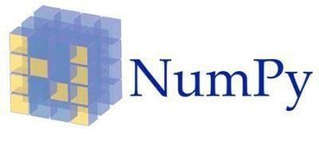

NumPy is a very popular python library for large multi-dimensional array and matrix processing, with the help of a large collection of high-level mathematical functions. It is very useful for fundamental scientific computations in Machine Learning. It is particularly useful for linear algebra, Fouriertransform,andrandomnumbercapabilities.

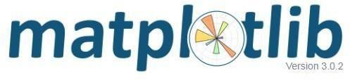
Matplotlib is a very popular Python library for data visualization. Like Pandas, it is not directly related to Machine Learning. It particularly comes in handy when a programmer wants to visualize the patterns in the data. It is a 2D plotting library used for creating 2D graphs and plots. A module named pyplot makes it easy for programmers for plotting as it provides features to control line styles, font properties, formatting axes, etc. It provides various kinds of graphs and plots for data visualization, viz., histogram, error charts, bar chats etc.


Scikit-learn is one of the most popular ML libraries for classical ML algorithms. It is built on top of two basic Python libraries, viz., NumPy and SciPy. Scikit-learn supports most of the supervised and unsupervised learning algorithms. Scikit-learn can also be used for data-mining and data- analysis, which makes it a great tool who is starting out with ML.

CLASSIFICATION AND VISUALIZATION PART

SCREEN SHOT DATA SET:-

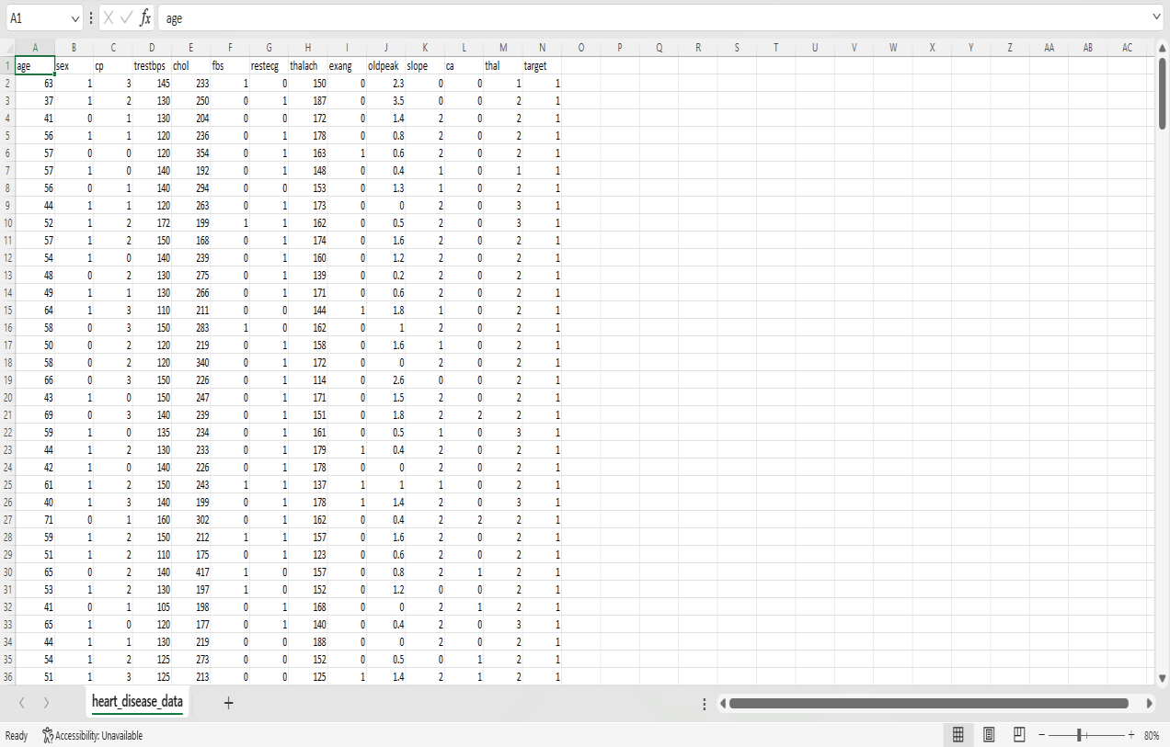

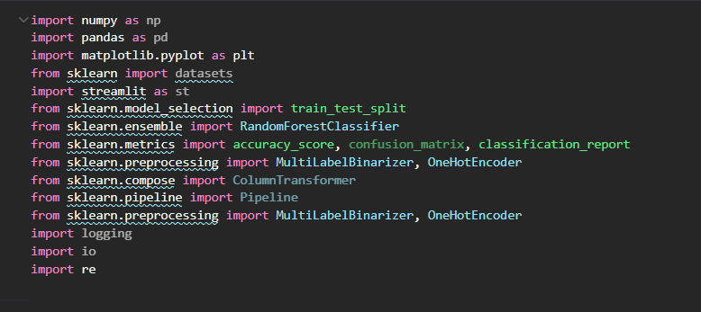
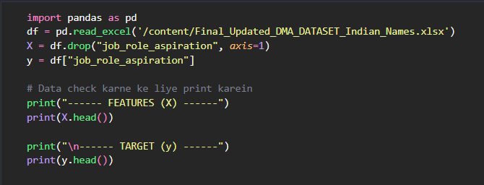

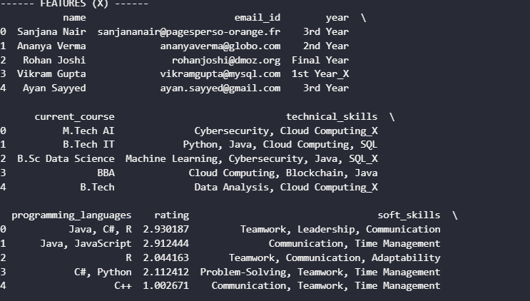
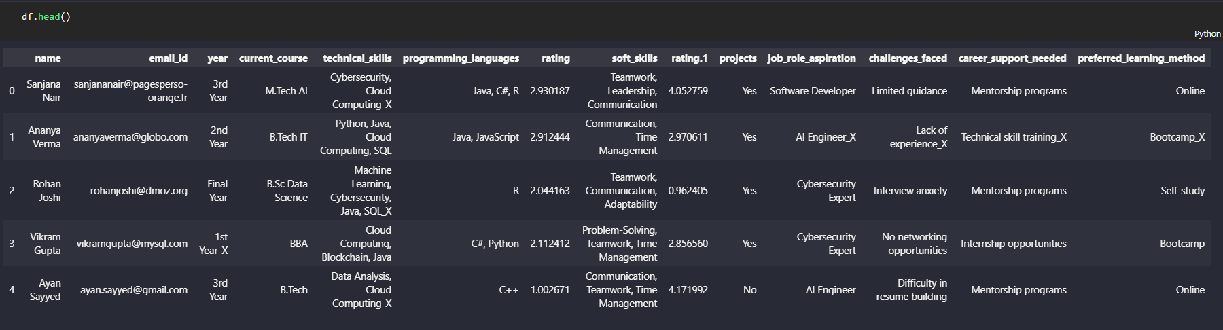
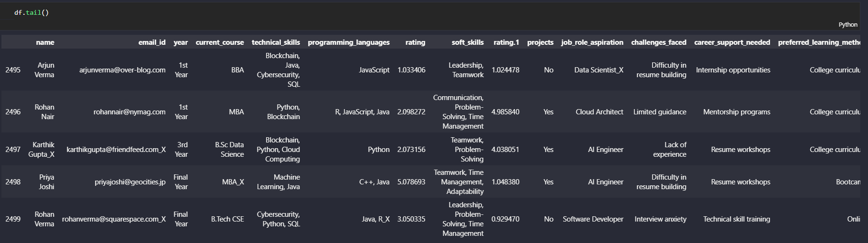

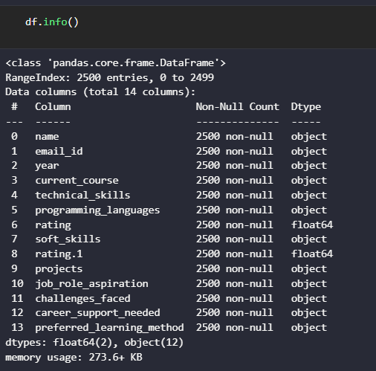

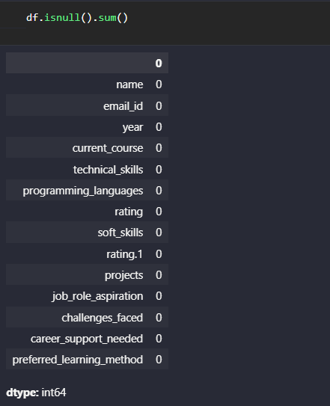

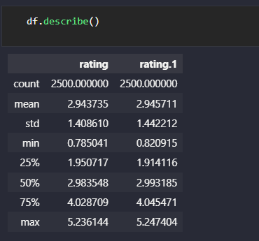
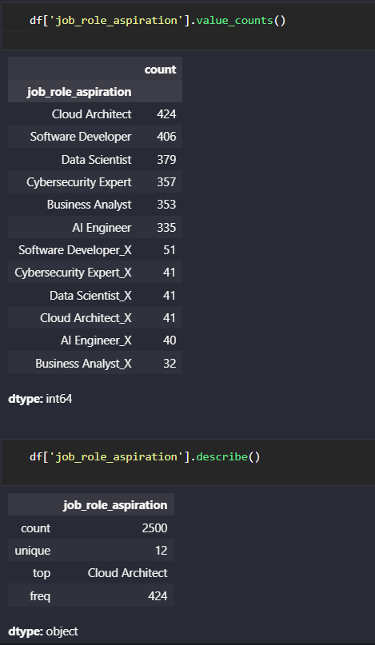

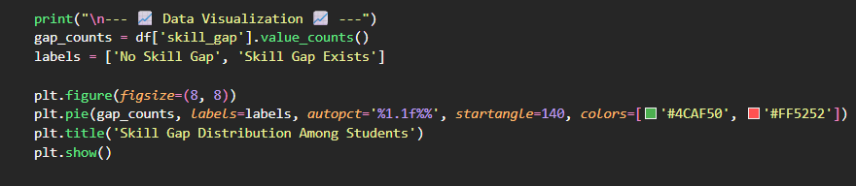

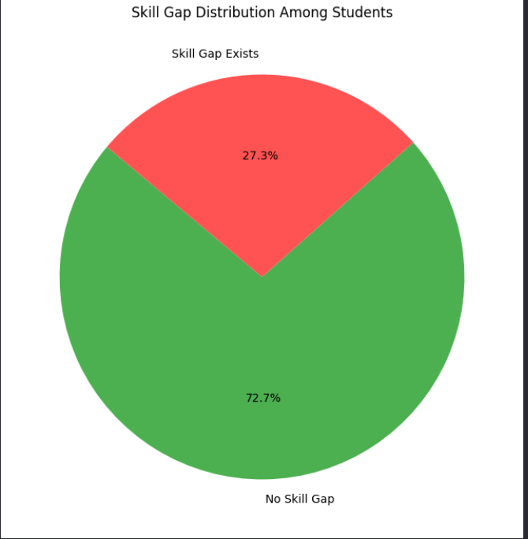

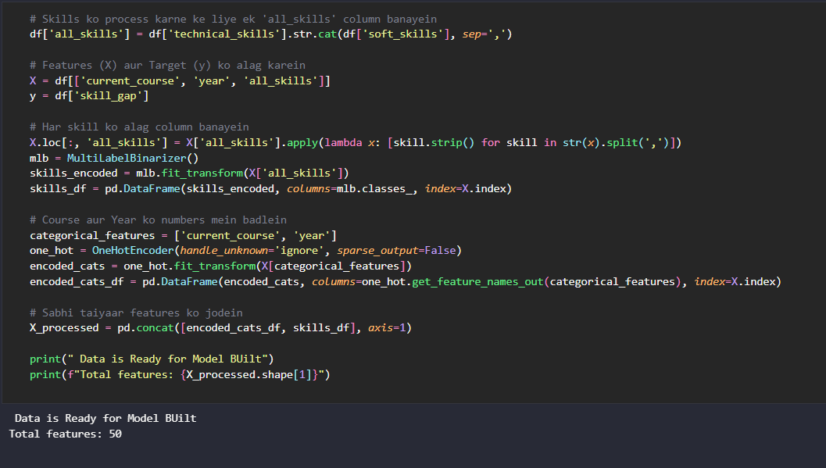

- SPLITTING AND MODEL IMPLEMENTATION &

- ACCURACY OF ALL IMPLEMENTED MODELS

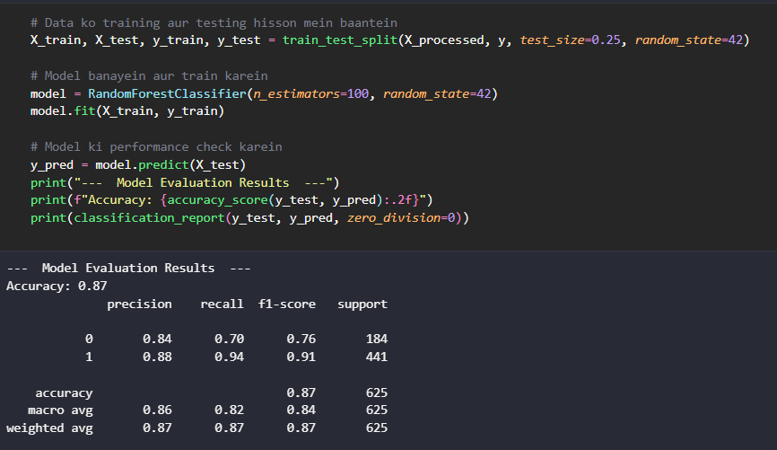

- BUILDING A USER INPUT PREDICTIVE SYSTEM

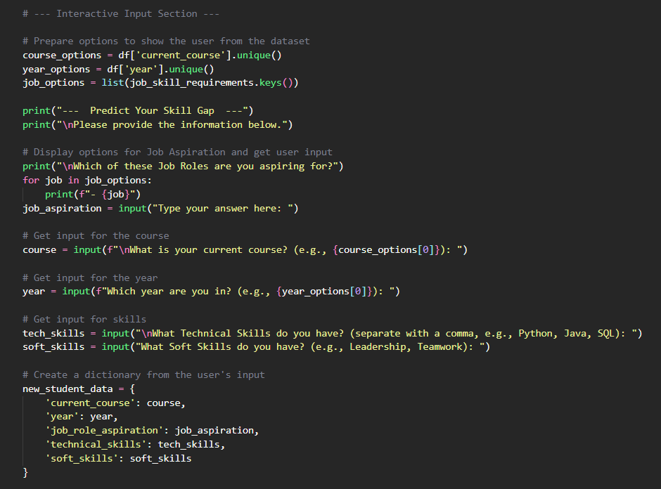

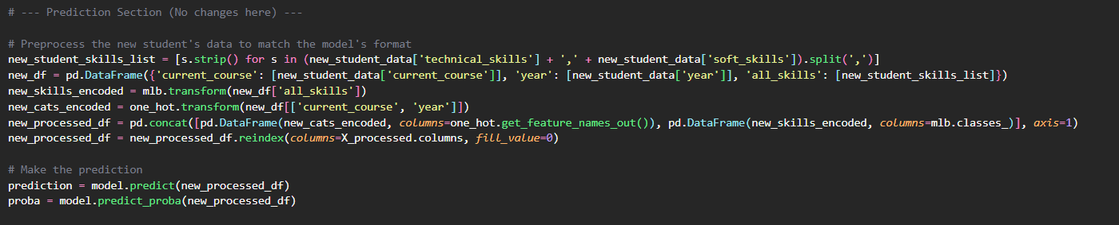

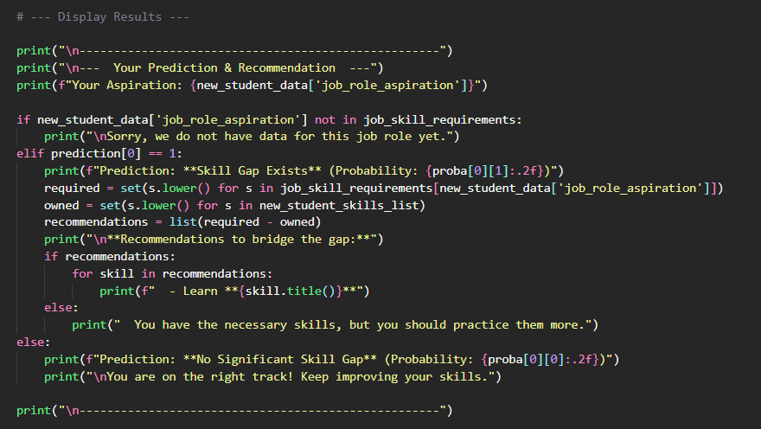

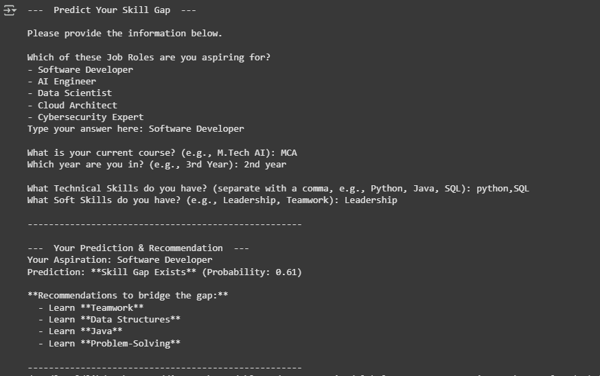

Conclusion
The early prognosis of cardiovascular diseases can aid in making decisions on lifestyle changes in high-risk patients and in turn reduce the complications, which can be a great milestone in the field of medicine. This project resolved the feature selection with the models used like DecisionTreeClassifier, Logistics Regression, KNeighborsClassifier, Gaussian NB and Random Forest Classifier. It successfully predicts the heart disease, with 85% accuracy. Further for its enhancement, we can train on models and predict the types of cardiovascular diseases providing recommendations to the users, and also use more enhanced models.

- FUTURE SCOPE

The future scope of a heart disease prediction project using machine learning (ML) is promising and multifaceted. Advancements in ML techniques will likely lead to more accurate predictive models, incorporating sophisticated algorithms and ensemble methods. Integration of medical imaging, personalized medicine, and continuous real-time monitoring through wearables and IoT devices could enhance predictive accuracy. Future projects may prioritize explainable AI, addressing data privacy, and collaborating closely with healthcare providers for seamless integration into clinical practice. Emphasizing continuous learning and model updating, alongside considerations for public health initiatives and global health applications, can contribute to broader impacts on cardiovascular health. The success of these projects depends not only on technical advancements but also on ethical considerations and collaboration with healthcare professionals to ensure real-world effectiveness and adherence to regulatory standards.

REFERENCE

  - https://www.analyticsvidhya.com

/blog/2022/02/heart-disease- prediction-using-machine-learning/
  - J. Ma, W. Gao, P. Mitra, S. Kwon, B. J. Jansen, K.-F. Wong, and M. Cha, “Heart diseases
prediction.,” in IJCAI, pp. 3818–3824, 2016.
  - Z. Jin, J. Cao, H. Guo, Y. Zhang, Y. Wang, and J. Luo, “Heart diseases prediction,” arXiv preprint arXiv:1701.06250, 2017.
  - L. Derczynski, K. Bontcheva, M. Liakata, R. Procter, G. W. S. Hoi, and A. Zubiaga, “Semeval-2017 task 8: Rumoureval: Determining Heart diseases prediction,” arXiv preprint arXiv:1704.05972, 2017.
  - X. Cao, T. Le, and J. Zhang, “Machine learning based detection of Heart diseases prediction,”

ASSESSMENT
Internal:

SL NO | RUBRICS | FULL MARK | MARKS OBTAINED | REMARK S
1 | Understanding the relevance, scope and dimension of the project | 10
2 | Methodology | 10
3 | Quality of Analysis and Results | 10
4 | Interpretations and Conclusions | 10
5 | Report | 10
 | Total | 50

Date: Signature of the Faculty

COURSE OUTCOME (COs) ATTAINMENT

- Expected Course Outcomes (COs):
(Refer to COs Statement in the Syllabus)
_
_
_
_
- Course Outcome Attained:
How would you rate your learning of the subject based on the specified COs?





1 2 3 4 5 6 7 8 9 10
LOW HIGH
- Learning Gap (if any):

- Books / Manuals Referred:
_
_
_
_

Date: Signature of the Student
- Suggestions / Recommendations:
(By the Course Faculty)
_
_
_
_

Date: Signature of the Faculty

